1. Brandon Kmiec, Assignment 1, CSC 155, Section 2, Spring 2024.
2. Screenshot of running program.

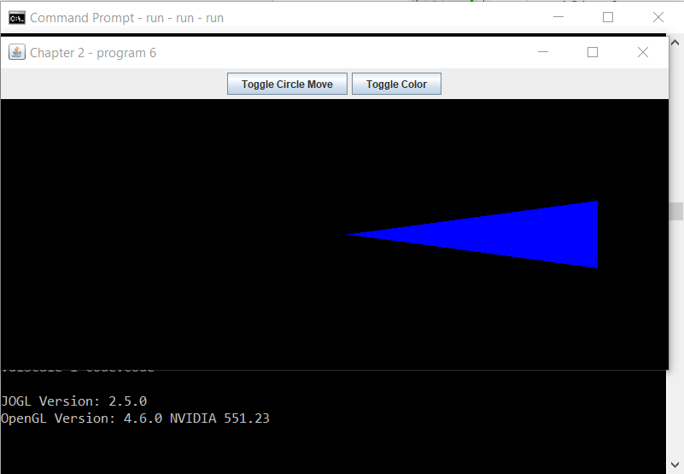

1. Program requirements I was able to fully implement:
   1. The triangle must be isosceles and narrow.
   2. Movement must be based on elapsed time.
   3. Display the current JOGL and OpenGL versions to the console at startup.
   4. A button that causes the triangle to move and stop moving in a circle.
   5. A button to toggle the color of the triangle between Blue, Green, Orange, and a gradient of the three.
   6. The 1 key cycles the triangle through four directions.
   7. The mouse wheel increases or decreases the size of the triangle.
2. Program requirements I was not able to fully implement:
   1. N/A
3. Instructions:
   1. Open Command Prompt and navigate to the folder containing the bat files.
      1. OR, open the file explorer and navigate to the folder containing the bat files. Then double click “compile” and then “run”. Skip to step 3.
   2. Type “compile” and then “run”.
   3. Once running, click anywhere in the background and press “1” on the keyboard to change the direction from Left to Up. Press “1” again to change the direction from Up to Right. Press “1” again to change the direction from Right to Down. Press “1” one more time to change the direction from Right back to Left.
   4. Click the button “Toggle Circle Move” to make the triangle move in a circle. Click the button again to make the triangle move left to right.
   5. Click the button “Toggle Color” to change the color from Blue to Green. Click the button again to change the color from Green to Orange. Click the button again to change the color from Orange to a Gradient of Blue, Green, and Orange. Click the button one more time to change the color from the Gradient back to Blue.
   6. Scroll the mouse wheel forward to Decrease the size of the triangle. Scroll the mouse wheel backwards to Increase the size of the triangle.
   7. Ready to close the program? Click anywhere in the background and press the “Esc” on the keyboard.
4. Tested on RVR-5029 RAYMAN.